Barker College Touch Panel UI Proposed Layout

Start Page, when the system is off



After pressing this, the system indicates it is busy whilst it sets default parameters up.

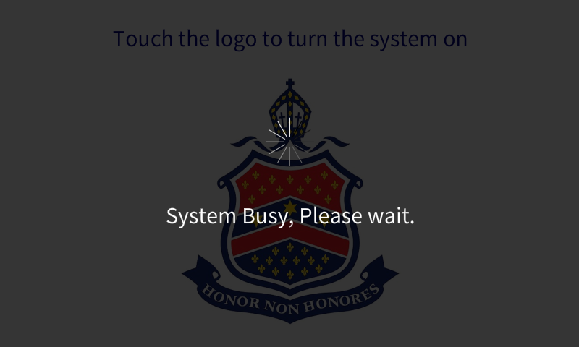

Once completed, the user is presented to the main screen with a welcome message

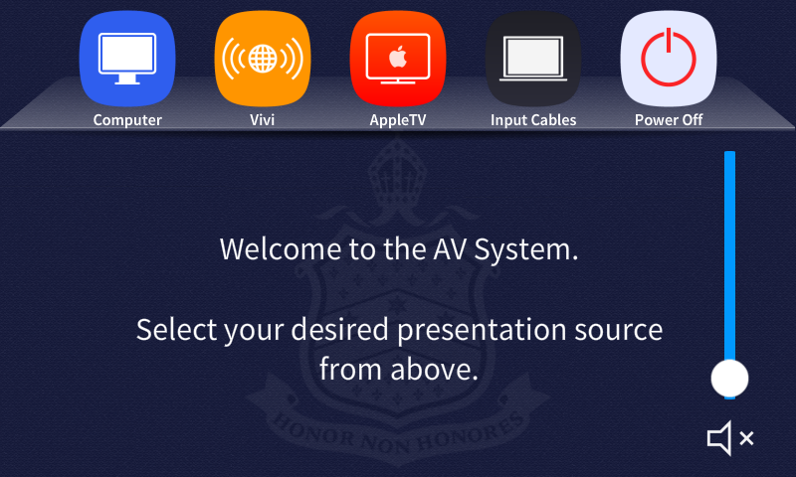

Selecting a source will turn the projector on, and the audio for this source will be heard through the soundbar.

Volume controls are controlled by sliding your finger on the white dot, mute is by pressing the mute icon below the slider.

Computer Selection

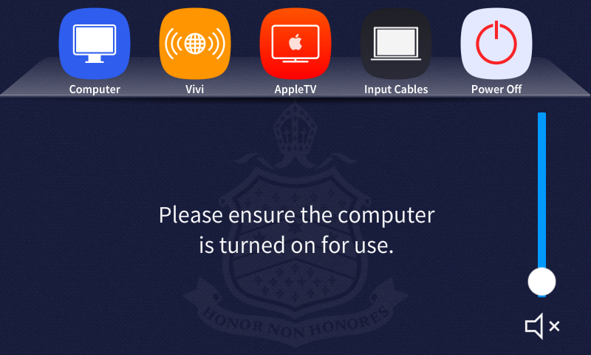

Vivi Wireless presentation

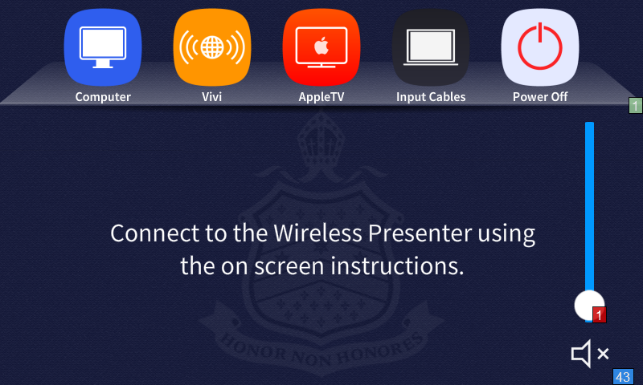

AppleTV Selection

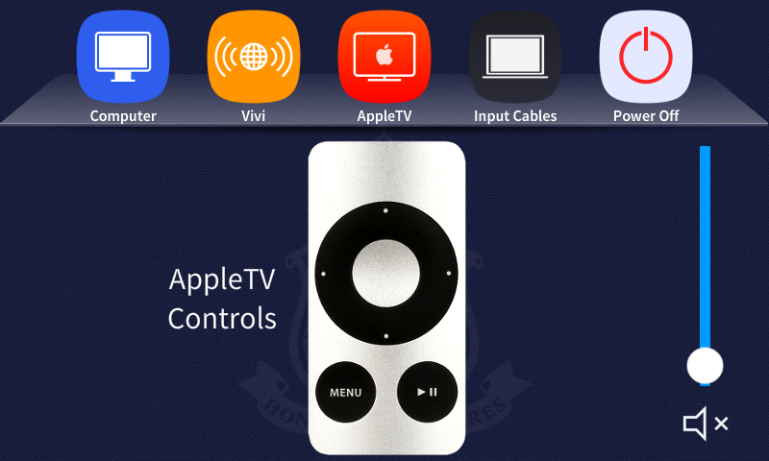

Pressing the buttons on the remote control on this page will control the appletv accordingly.

Spare Input HDMI and VGA cables

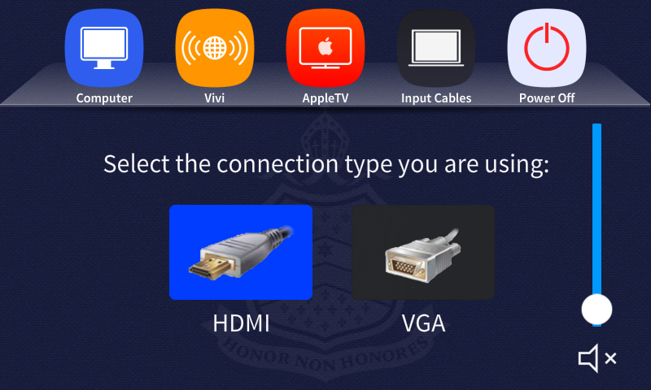

Power Off

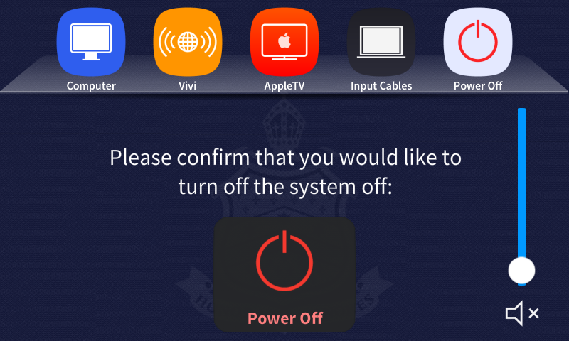

Pressing this button will power off the projector, stop all audio from being heard, and present a busy message whilst this occurs.

Busy

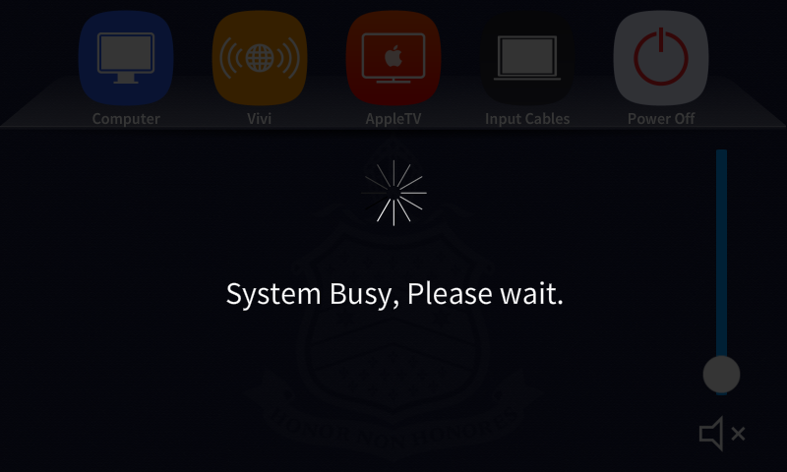

Once completed the process, the panel returns to the start page as shown in the start of this document.